Welcome to the Cody’s Original Roadhouse Hourly Training Program. We are excited for you to be a part of our team and to teach you everything we can in order for you to be a success at Cody’s. Please fill in the facts below so that you can have the proper information if something is to arise during your training process. Please bring this study guide and quiz packet to class every day.

Cody’s Original Roadhouse Restaurant Information

1. **MANAGEMENT STAFF:**

GENERAL MANAGER: ___________________________ MANAGER: ___________________________

MANAGER: ___________________________

KITCHEN MANAGER: ___________________________

2. **ADDRESS: _______________________________________________________**

3. **PHONE NO: _____________________**

**WEBSITE ADDRESS:** www.codysoriginalroadhouse.com

4. **HOURS OF OPERATION:**

OPEN 7 DAYS PER WEEK

Monday thru Thursday: 3:00 PM - 10 PM

Friday and Saturday: 3:00 PM – 11 PM

Sunday: 11:00 AM - 10 PM

**NOTE:** **Opening & Closing times may vary – check your restaurant hours.**

**NOTE:** Restaurants Restaurant is always ready 15 minutes prior to opening. Also, will stay open 15 minutes past posted closing time.

|  |  |  |  |
| --- | --- | --- | --- |
| Training Schedule for the Week | | | |
|  | Date | Time | Trainer |
| Day 1 |  |  |  |
| Day 2 |  |  |  |

Server Assistant Training Process Overview

**Options for training times:**

2:00-3:00 Class with Food Show and Quiz Review

3:00-8:00 Pre-Meal/Follow

8:00-8:30 POS Practice

**OR**

4:45-8:30 Pre-Meal/Follow

8:30-9:00 POS Practice

9:00-10:00 Class with Food Show and Quiz Review

DAY 1

***Class Topics-***

• Go over numbered floor chart (***Need: Restaurant specific numbered floor chart)***

• Clock in & Out Procedures

• Tip Share

* Server Assistant Standards
* Parking Lot Procedures
* How to Clean a Table

***Follow Topics-***

• Round Robin: 30 minutes in each area. SERVER ASSISTANT, HOST, EXPO

* Server Assistant- Observe bussing the table, proper table sanitation procedures, proper table set up, proper dish stacking procedures, restroom checks and trash runs
* Host- Observe phone procedures, proper menus handed out, walk and talk, catering to our kids, seating rotation using floor chart, interaction with guests, and phone procedures
* Expo- Manager and/or Food Runner in window out explains Picture Perfect Plate Presentations and menu descriptions

Clock In/Out Procedure/Tip Share

**Clocking in**: Touch the screen to bring up key pad. Enter employee number. Select server assistant button. Select Clock in button. Retrieve Chit sheet from printer. You may not clock in early or stay late without manager approval.

**Clock out Procedures**: Touch Screen to bring up key pad. Enter employee number. Select clock out button. Select clock out button. Retrieve chit sheet from printer (retain for your records). Do assigned side work before clocking out (men’s restroom, empty trash).

**Tip share:** Tip share is a portion of your wage you receive that goes towards your pay. It is paid by servers based on their sales. At the end of each shift a manager will calculate tip share based on the hours you worked. You may pick up your tip share on pay day. All tip share amounts must be claimed.

Server Assistant Standards

* Be on time in a proper and clean uniform
* Check in with management for any 911 duties
* Set up bathroom station: Sani bucket, towels, toilet paper, paper towel, plunger, soap, sanitation bags (women’s room), urinal screens (men’s room), key for dispensers, wet floor sign
* Ensure trash cans are set up throughout the restaurant
* Ensure all paper towel and soap dispensers are full throughout the restaurant
* Check all sani buckets are set up throughout the restaurant
* Assist in any prep, silverware rolling, etc.
* Get a fresh, labeled sanitizer spray bottle, 1 wet towel, 1 dry towel, a dry seat towel
* Sanitize and dry entire table surface as well as the chair/booth
* Clean and reset table with within 60 seconds of guest departure
* Communicate open tables to the Host
* Completely scrape each dish before stacking in the dish area
* Stack plates and place silverware in the correct area
* Use a clean bus tub to carry dishes to the dish area (rinse often)
* Make sure condiments are set up correctly in the caddy and wiped down
* Check for trash on the floor and under tables
* When not bussing tables, assist servers by filling ice and stocking glasses, assist dish with trash runs
* Check restrooms every 15 minutes
* Help other server assistants with tables
* Always take bar glasses to the bar (they are fragile and must be hand washed)
* Help move tables for large parties or break apart when a party leaves
* Always walk the guest to where they need to go (restroom, to go area, meet their party)
* Always acknowledge a guest by saying hello
* Recognize regulars
* Wash your hands

Parking Lot Procedures

* Always check parking lot at the beginning of your shift and throughout your shift every hour
* You will need a broom, dustpan, gloves and a trash bag
* Remove all trash around the building (including rocks and flower beds)
* Sweep up/ pick up cigarette butts
* Check ashtrays by front door

How to Clean a table

To properly sanitize a table, you will need a roll of paper towels and the purple K84 Sink & Surface Sanitizer

(#5662037 on the US Foods Order Guide).

Remove all dishes from the table and place in clean bus tub. Remove the bus tub from the table and carry it directly into the kitchen’s dish machine area.

Remove all trash including the butcher paper and place into a trash receptacle.

Spray table with K84 and wipe entire table including the sides. Allow chemical to sit for 30 seconds before wiping. Wipe entire table and under caddies and condiments with a one-time use paper towel.

Spray the seats with K84, wait 30 seconds and wipe with paper towel.

Always clean tabletop first, then clean seats.

After wiped, allow all areas to air dry.

Reset condiments while making sure they are clean. Use a paper towel sprayed with K84 to wipe off each condiment.

Cover table with white butcher paper. Ensure the piece is cut evenly from the roll and does not hang over the edges of the table.

Empty the peanut bucket if it is full of shells or peanut dust. Fill the bucket with fresh peanuts and return it to the table.

Place any POS material, crayons in small bucket and peanut bucket in their proper positions on the table.

Check under the table to ensure there is no trash, broken crayons or food remains. Pick up and dispose of any trash on the ground.

Spray K84 on all boosters and highchairs, wipe with paper towel and return to assigned storage area.

**Cody’s Original Roadhouse Server Assistant Day 1 Quiz**

**Name: _________________________________ Score ______/8**

1. What items do you need to properly sanitize a table?

A) Sanitizer Bottle and Paper Towel

B) Sanitized Towel, Dry Towel, Bus Tub

C) Sanitizer Bottle, Sanitized Towel, Dry Towel, Bus Tub, Seat Towel

D) Sanitizer Bottle, Damp Towel, Bus Tub

1. What items do you remove from the table?

A) Dishes

B) Dishes and Trash

C) Silverware and Cups

D) Any used cups, dishes, napkins, utensils

1. When do you claim tip share?

A) When you clock out

B) Never

C) When you clock in

D) At the end of the week

1. When can you pick up tip share?

A) Anytime

B) During dinner rush

C) On payday

D) After your shift

1. How long do you have after a guest leaves to reset a table?

A) 30 seconds

B) 60 seconds

C) 90 seconds

D) 3 minutes

1. When do you check the parking lot?

A) When it snows and every 15 minutes

B) Before your shift and every hour

C) After your shift

D) When it rains and every 20 minutes

1. What items do you need when checking the parking lot?

A) Broom and dustpan

B) Broom and trash bag

C) Gloves and a trash bag

D) Broom, dustpan, disposable gloves and a trash bag

1. List the steps to properly sanitize a table:

____ Step 1 A) Wipe booth seat/chairs with paper towel

____ Step 2 B) Wipe the tabletop with a paper towel

____ Step 3 C) Spray table with sanitizer

____Step 4 D) Set bus tub aside

____ Step 5 E) Place any POS material, crayons and peanut buckets on the table

____ Step 6 F) Wipe all highchairs/ booster seats with your seat towel

____ Step 7 G) Remove trash and dishes

____ Step 8 H) Return highchairs and booster chairs to storage area

____ Step 9 I) Reset condiments making sure they are clean

____ Step 10 J) Cover table with white butcher paper

Trainee Evaluation

**Day 1**

(Completed by trainer with trainee present and signed off by a manager)

1. Trainee arrived to work on time? Yes/No

2. Trainee arrived in proper uniform? Yes/No

3. Trainee attended classroom? Yes/ No

4. Was trainee involved and attentive to training procedures? Yes/ No

5. Does trainee accept constructive feedback? Yes/ No

Does trainee exhibit knowledge and understanding of clocking in/out procedures, how to claim tip share, parking lot and the process of cleaning a table procedures?

Trainer Signature ______________________________ Trainee Signature___________________________

Date ________________________________________ Manager Signature__________________________

Day 2

***Class Topics-***

* Proper Table Set Up
* FOH Cleanliness
* Stacking Dishes
* Restroom Checks
* Daily/Weekly Cleaning Chart
* A Day in the Life of a SA’s Shift

***Follow Topics-***

* Table Number Test
* Sanitizing the table
* Stacking dishes

Proper Table Set up

Condiment bottles clean and full.

Ketchup, Cody’s BBQ Sauce, Cody’s Steak Sauce, Cody’s All-Purpose Seasoning, Pepper & Saltshakers

(Always place the salt on the right of the pepper or in front of the pepper)

Peanut Bucket Clean and full of fresh peanuts

Any form of Table Point of sale

Bucket for crayons

Clean white butcher paper over table cover

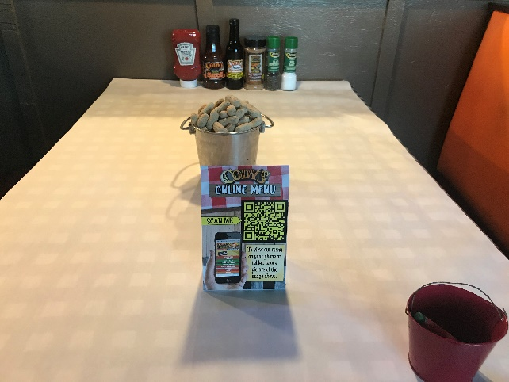

FOH Cleanliness

Server Assistants must take care of their Front of House areas through cleaning and sanitizing, not only for a healthy environment for our guests but for the team members as well.

A red bucket in the restaurant contains a sanitizing solution which will be used to clean all tables and surfaces. The solution should test no more than 200 PPM - 400PPM if it is a quat based sanitizer. (Some restaurants use disposable sanitizer towel which may be used also. These are a one-time use towel and must be thrown away after it is used). A third option is a Contact Surface Cleaner Sanitizer. Test strips are available through your managers.

The sanitizer bucket must be labeled and dated and have no more than 2 towels in it at any time. The towels must always be submerged in this solution when not in use. Change the water every 2 hours.

Stacking Dishes

Dishes must be stacked with like items to enable the dishwasher to be more efficient. Please remember to completely scrape all dishes completely and empty all cups.

* App plates with app plates
* Rounds with rounds
* Ovals with Ovals
* Salad bowls with salad bowls
* Bread baskets with bread baskets
* Place all red cups and coffee cups in correct cup rack
* Place all silverware in bus tub filled with silver soak
* Check trash Lexan frequently to ensure no silverware is being thrown away before emptying into trash can

Restroom Checks

* Restroom checks completed every 30 minutes.
* Initial the restroom log at the host stand once you have checked the restroom.
* Restrooms should be stocked with toilet paper in each stall and hand towels in each dispenser.
* Check soap dispensers to see if they need to be filled. Fill if empty.
* Make sure there is no trash on the floor and that they are dry.
* Check sanitary trash receptacles and make sure they are not full (replace liner if necessary).
* Flush toilets as needed and wipe seats as necessary.
* Check trash cans to make sure they are not overflowing.
* Counters need to be wiped down so they are dry and mirrors should be spot free.

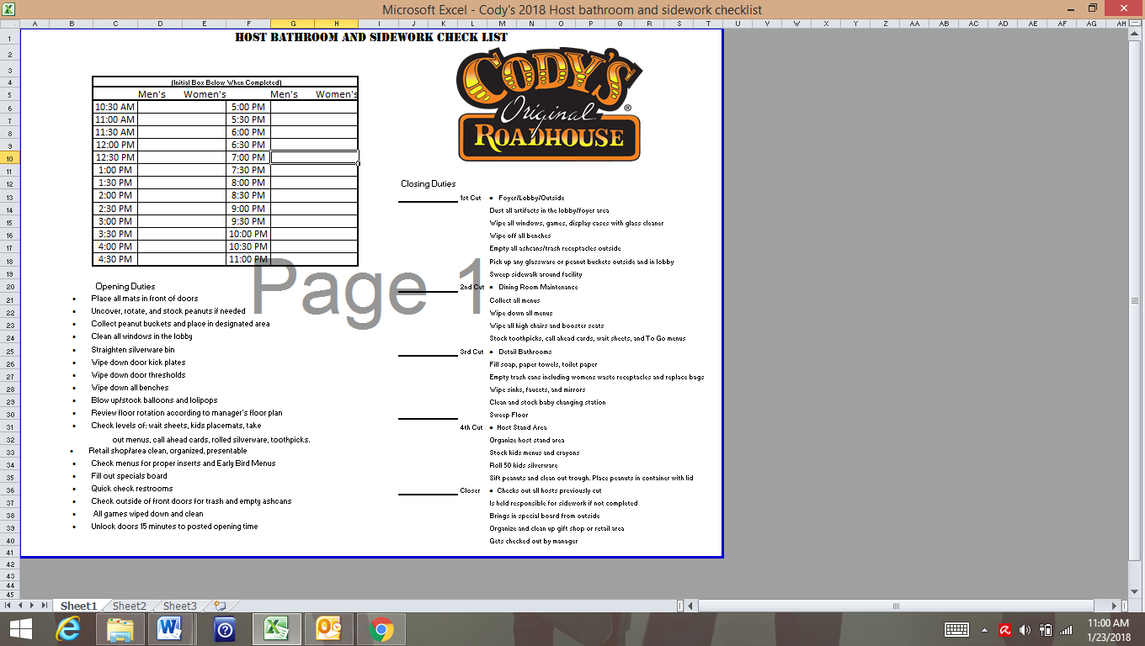

Daily/Weekly Cleaning Chart

When checking in for your shift, check this chart to tell you what the SA’s group cleaning duty is for the shift.

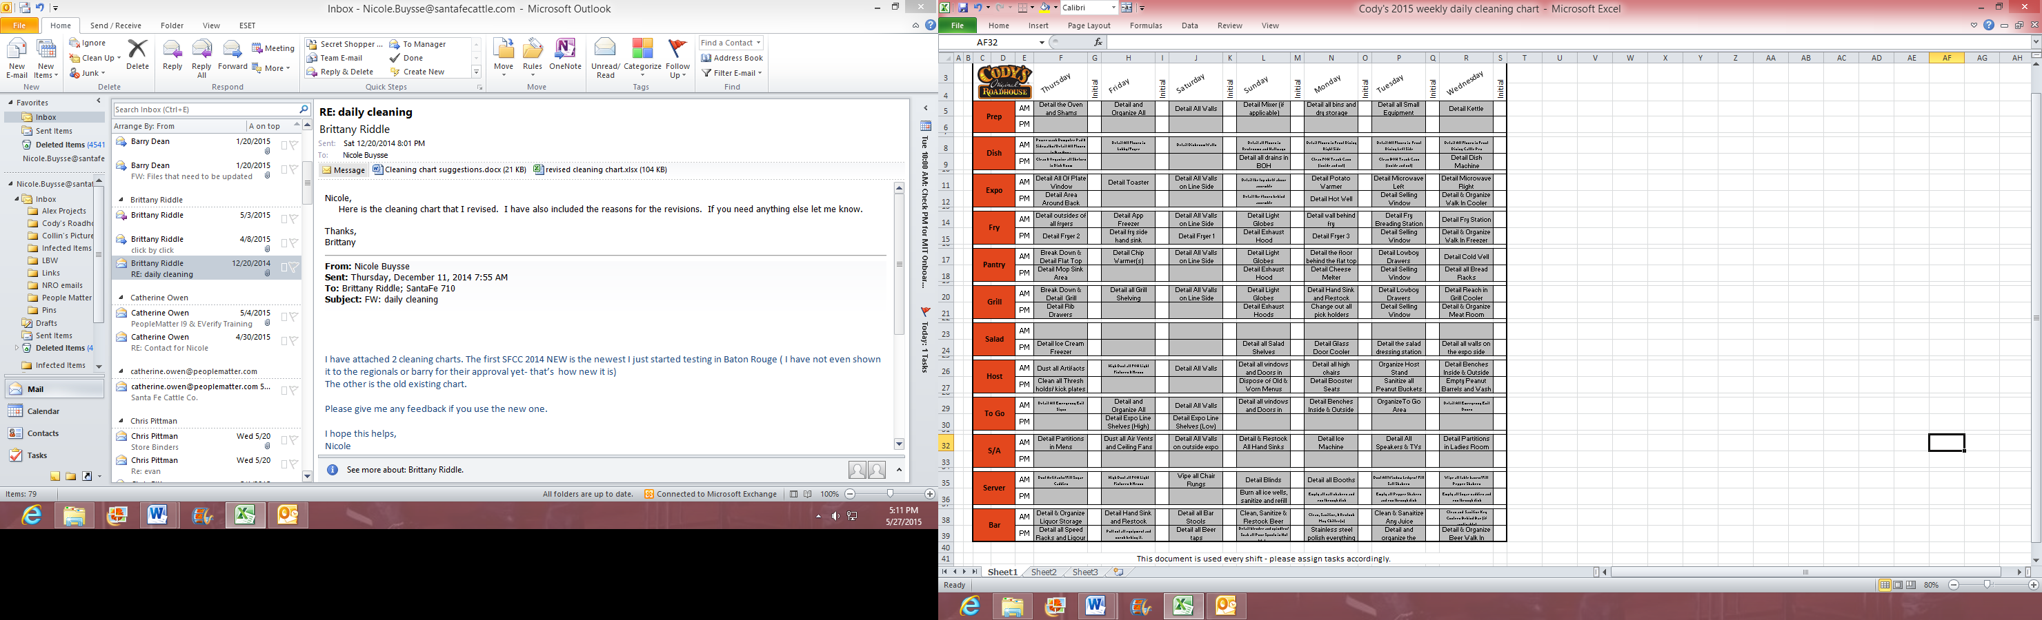

A Day in the Life of a SA’s Shift

**Before the Shift**

Make sure you arrive on time in proper uniform. Clock in: Touch the screen to bring up keypad. Enter employee number or swipe card. Select S/A button. Select Clock in button. Retrieve Chit sheet from printer. You may not clock in early or stay late without manager approval.

**During the Shift**

Follow proper table cleaning and set up procedures. Complete bathroom checks every 15 minutes. Check the parking lot every hour. Provide assistance to fellow team members, make sure all areas in the FOH are clean and guest ready.

**Side work**

Check assigned side work for your shift. Make sure to complete all items on your assigned side work completely including your continual duties throughout the shift.

**After the Shift**

Complete all closing side work thoroughly. Pull bus tub from bar. Take any garbage out as needed/side stations, dish drop off area. Check restrooms/stock clean counter tops dry. Break down sanitizer bucket in bathroom station and restock towels and paper. Break down any boxes in the back dock. Have your side work checked out by the manager.Clock out: Touch Screen to bring up keypad. Enter employee number or swipe card. Select clock out button. Retrieve chit sheet from printer (retain for your records).

Trainee Evaluation

**Day 2**

(Completed by trainer with trainee present and signed off by a manager)

1. Trainee arrived to work on time? Yes / No

2. Trainee arrived in proper uniform? Yes / No

3. Trainee attended classroom? Yes / No

4. Was trainee involved and attentive to training procedures? Yes / No

5. Does trainee accept constructive feedback? Yes / No

Trainer Signature ____________________________________

Trainee Signature____________________________________

Date ______________________________________________

Manager Signature _________________________________

**Cody’s Original Roadhouse Server Assistant Final Test**

**Name: _________________________________ Score ______/8**

1. What should you do before, during and after your shift?

____ Before A) Complete All Closing Side work

____ During B) Assist fellow Team Members

____After C) Arrive in Proper Uniform

1. How many rolled silverware go a table?

A) The amount the table/booth seats

B) 2

C) 4

D) 6

1. Explain proper stacking procedures:

A) Like with Like

B) Wherever they will fit

C) Rounds with Ovals

D) Soup Cups with Salad Bowls

1. How often should you check the restroom?

A) Every 5 minutes

B) Every 10 minutes

C) Every 15 minutes

D) Every 30 minutes

1. List 5 things you check in the restroom:

A) Paper Towels, Soap, Toilet Paper, Trash Levels, TV Channels

B) Counters, Trash, Mirrors, Toilet Paper, Cell Phone

C) Paper Towels, Soap, Counters, Trash, Toilet Paper

D) Paper Towels, Soap, Trash, Lottery Numbers, Toilet Paper

1. Where is the restroom log located?

A) The Host Stand

B) The Manager’s Office

C) In the Restroom

D) At the Bar

1. What is a way you can assist a server?

A) Rub Their Feet

B) Help Pre-bus Their Table

C) Sweep Their Section

D) None of the Above

1. What is something you can do to assist the guest?

A) Open their car door

B) Walk their dog

C) Walk them to the restroom or to go area

D) Pull out their chair for them